Assignment No.1
Part A :-
Create a responsive web page which shows the ecommerce /college /exam admin dashboard with sidebar and statistics in cards using HTML, CSS and Bootstrap.

We need text editor this assignment we will use VSCode Editor.
Open a folder inside vscode
Create a webpage as Register.html as we are creating registration form.
Now just type html then html boiler body will be displayed and select it.
Change the title to Sign Up |Sandeep Arts.
Now before moving to Bootstrap lets understand what is bootstrap and frontend framework?
Bootstrap is a free and open source front end framework which is used for creation of website and web apps. It is built on HTML, CSS and JavaScript.
We can make the responsive and mobile first websites.
For this assignment we need some CDN or bootstrap CSS file. For that go to browser search for get bootstrap and from first link https://get.bootstrap.com click on it then click on the read the docs.
Here you will see the link of CDN
From homepage Include via CDN
<link href="https://cdn.jsdelivr.net/npm/bootstrap@5.3.5/dist/css/bootstrap.min.css" rel="stylesheet" integrity="sha384-SgOJa3DmI69IUzQ2PVdRZhwQ+dy64/BUtbMJw1MZ8t5HZApcHrRKUc4W0kG879m7" crossorigin="anonymous">
Now go to VSCode editor copy this part of code into the head part of the html code/page.
This looks very big line just wordwrap it from menu view Wordwrap
Code looks big line not being readable
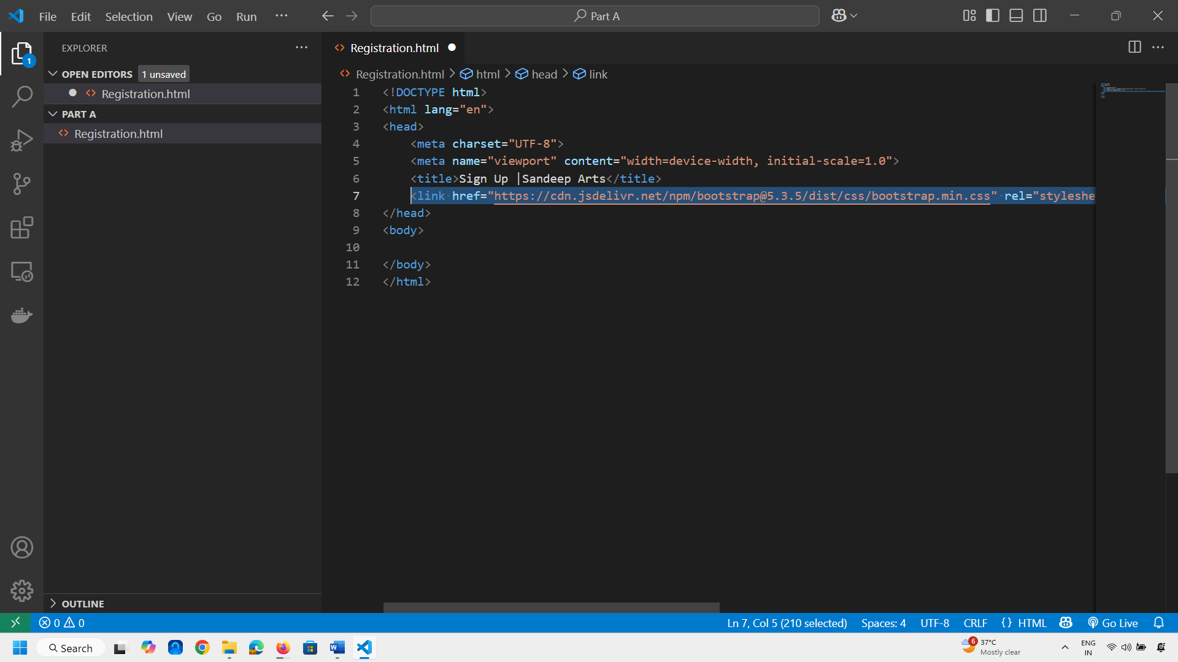
After Wordwrap
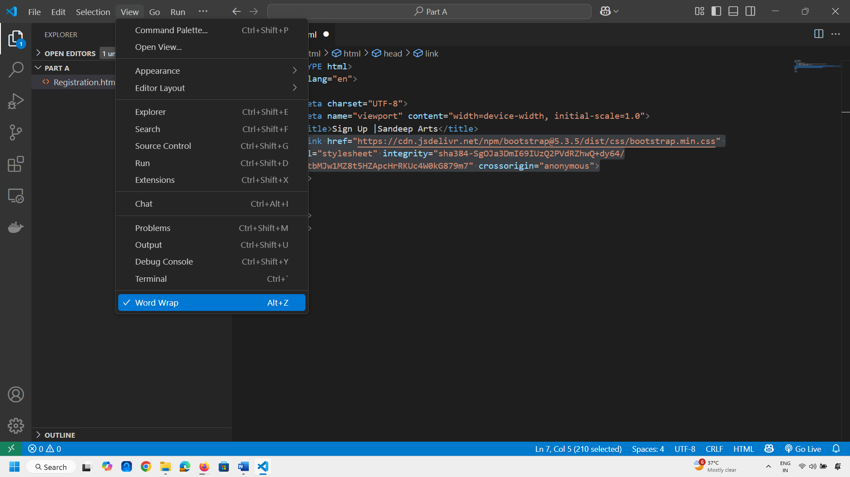
If you include this CDN code then you need internet connection.
Now do one thing copy the link https://cdn.jsdelivr.net/npm/bootstrap@5.3.5/dist/css/bootstrap.min.css
And paste it in browser to see what it has actually.
Save this code on computer in my case the path is D:\LP 2 Assignments\Assignment 1\Part A with extension css file name is bootstrap_css.css

Now we will include this file within head part of html document as follows
Type link in vscode editor you will get that code line
<link rel="stylesheet" href="bootstrap_css.css"> this file bootstrap_css.css should be inside the same directory so that it can easily locate the file.
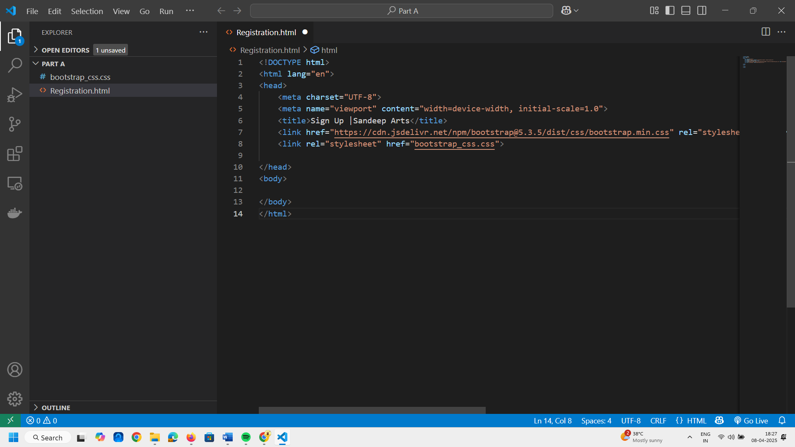
As I have included the file now we can comment the above line of the code.
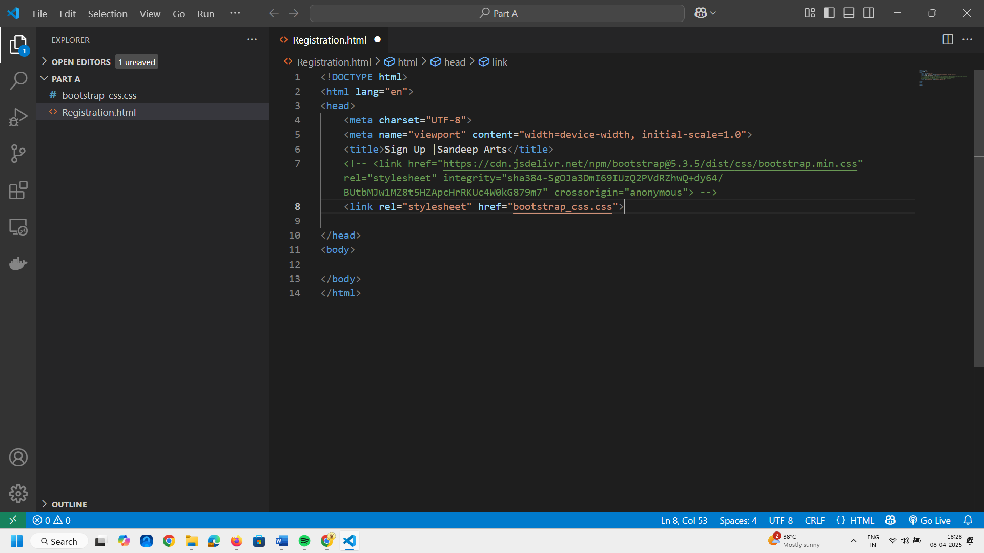

Now we have included this file i.e., css file.
Next task is now to create the form. Go to the browser and type bootstrap registration form
Click on the first link i.e., https://mdbootstrap.com/docs/standard/extended/registration/
Select any template you wish
We will select Full page registration template
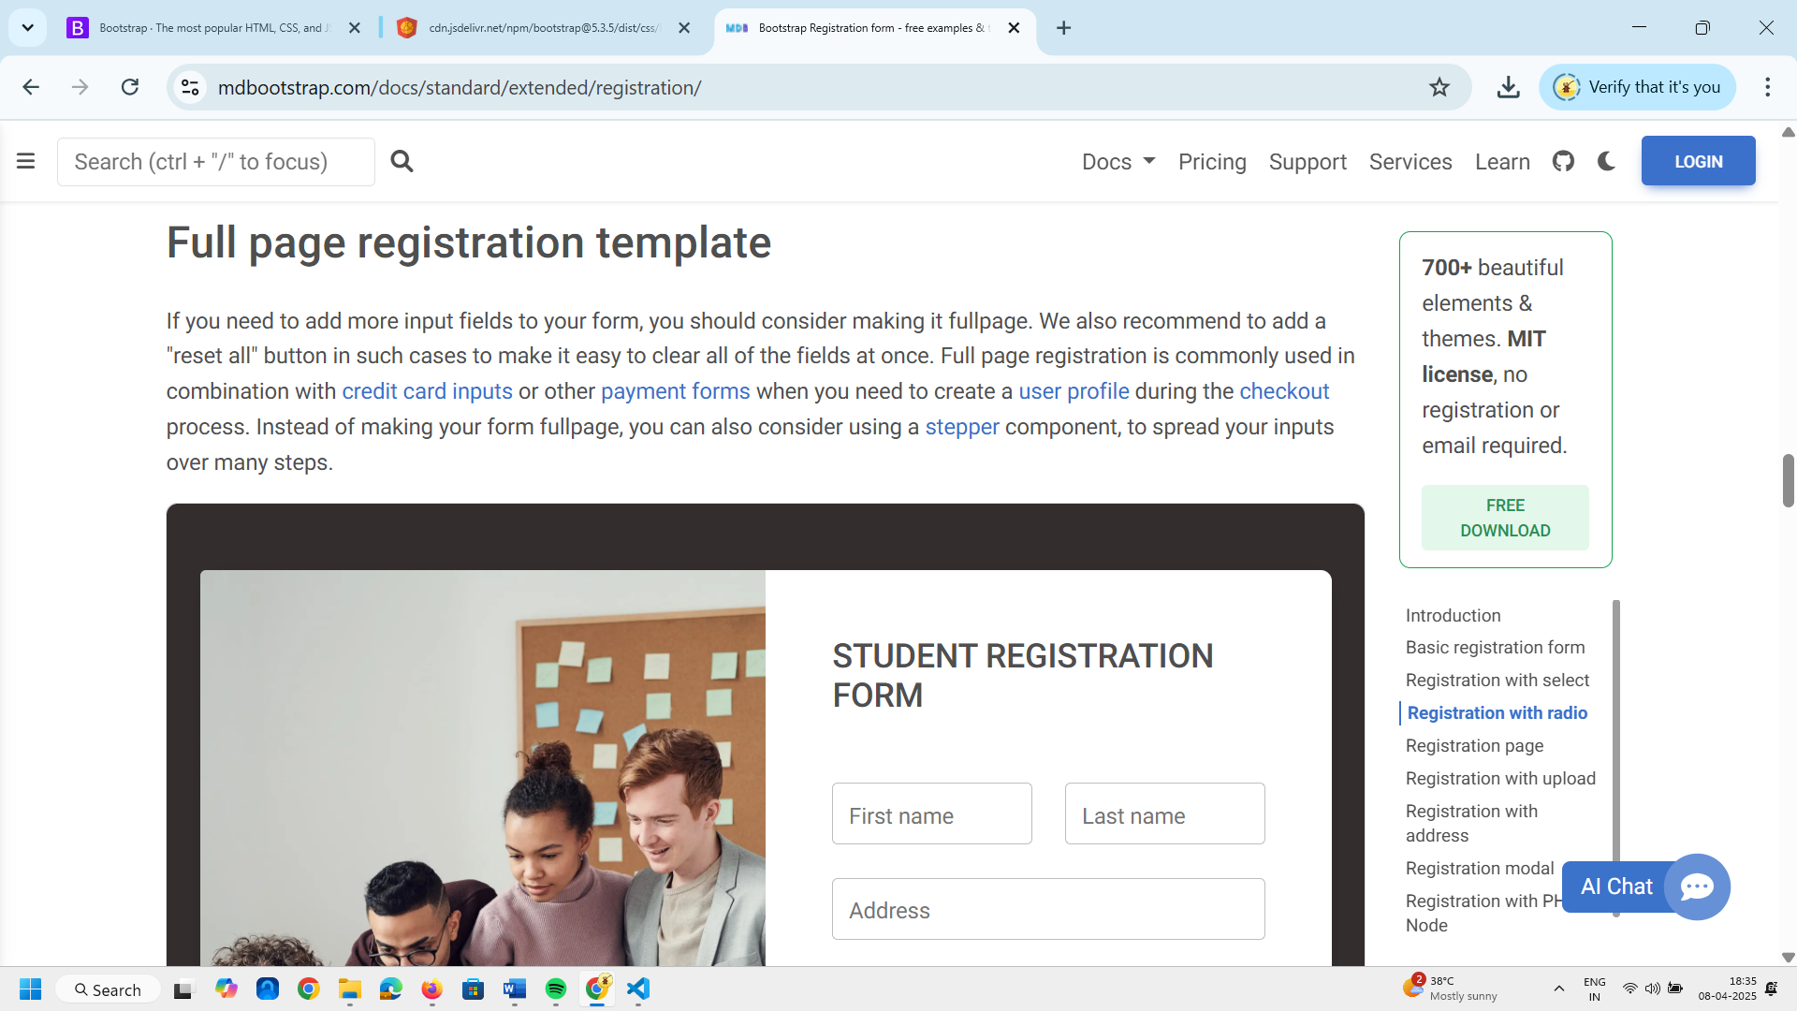
Now click on the SHOW CODE below the image
Copy the html code
<section class="h-100 bg-dark">
<div class="container py-5 h-100">
<div class="row d-flex justify-content-center align-items-center h-100">
<div class="col">
<div class="card card-registration my-4">
<div class="row g-0">
<div class="col-xl-6 d-none d-xl-block">
<img src="https://mdbcdn.b-cdn.net/img/Photos/new-templates/bootstrap-registration/img4.webp"
alt="Sample photo" class="img-fluid"
style="border-top-left-radius: .25rem; border-bottom-left-radius: .25rem;" />
</div>
<div class="col-xl-6">
<div class="card-body p-md-5 text-black">
<h3 class="mb-5 text-uppercase">Student registration form</h3>

<div class="row">
<div class="col-md-6 mb-4">
<div data-mdb-input-init class="form-outline">
<input type="text" id="form3Example1m" class="form-control form-control-lg" />
<label class="form-label" for="form3Example1m">First name</label>
</div>
</div>
<div class="col-md-6 mb-4">
<div data-mdb-input-init class="form-outline">
<input type="text" id="form3Example1n" class="form-control form-control-lg" />
<label class="form-label" for="form3Example1n">Last name</label>
</div>
</div>
</div>

<div class="row">
<div class="col-md-6 mb-4">
<div data-mdb-input-init class="form-outline">
<input type="text" id="form3Example1m1" class="form-control form-control-lg" />
<label class="form-label" for="form3Example1m1">Mother's name</label>
</div>
</div>
<div class="col-md-6 mb-4">
<div data-mdb-input-init class="form-outline">
<input type="text" id="form3Example1n1" class="form-control form-control-lg" />
<label class="form-label" for="form3Example1n1">Father's name</label>
</div>
</div>
</div>

<div data-mdb-input-init class="form-outline mb-4">
<input type="text" id="form3Example8" class="form-control form-control-lg" />
<label class="form-label" for="form3Example8">Address</label>
</div>

<div class="d-md-flex justify-content-start align-items-center mb-4 py-2">

<h6 class="mb-0 me-4">Gender: </h6>

<div class="form-check form-check-inline mb-0 me-4">
<input class="form-check-input" type="radio" name="inlineRadioOptions" id="femaleGender"
value="option1" />
<label class="form-check-label" for="femaleGender">Female</label>
</div>

<div class="form-check form-check-inline mb-0 me-4">
<input class="form-check-input" type="radio" name="inlineRadioOptions" id="maleGender"
value="option2" />
<label class="form-check-label" for="maleGender">Male</label>
</div>

<div class="form-check form-check-inline mb-0">
<input class="form-check-input" type="radio" name="inlineRadioOptions" id="otherGender"
value="option3" />
<label class="form-check-label" for="otherGender">Other</label>
</div>

</div>

<div class="row">
<div class="col-md-6 mb-4">

<select data-mdb-select-init>
<option value="1">State</option>
<option value="2">Option 1</option>
<option value="3">Option 2</option>
<option value="4">Option 3</option>
</select>

</div>
<div class="col-md-6 mb-4">

<select data-mdb-select-init>
<option value="1">City</option>
<option value="2">Option 1</option>
<option value="3">Option 2</option>
<option value="4">Option 3</option>
</select>

</div>
</div>

<div data-mdb-input-init class="form-outline mb-4">
<input type="text" id="form3Example9" class="form-control form-control-lg" />
<label class="form-label" for="form3Example9">DOB</label>
</div>

<div data-mdb-input-init class="form-outline mb-4">
<input type="text" id="form3Example90" class="form-control form-control-lg" />
<label class="form-label" for="form3Example90">Pincode</label>
</div>

<div data-mdb-input-init class="form-outline mb-4">
<input type="text" id="form3Example99" class="form-control form-control-lg" />
<label class="form-label" for="form3Example99">Course</label>
</div>

<div data-mdb-input-init class="form-outline mb-4">
<input type="text" id="form3Example97" class="form-control form-control-lg" />
<label class="form-label" for="form3Example97">Email ID</label>
</div>

<div class="d-flex justify-content-end pt-3">
<button type="button" data-mdb-button-init data-mdb-ripple-init class="btn btn-light btn-lg">Reset all</button>
<button type="button" data-mdb-button-init data-mdb-ripple-init class="btn btn-warning btn-lg ms-2">Submit form</button>
</div>

</div>
</div>
</div>
</div>
</div>
</div>
</div>
</section>
Paste above code inside the body part.
I have pasted the code now I will check whether it is working or not.

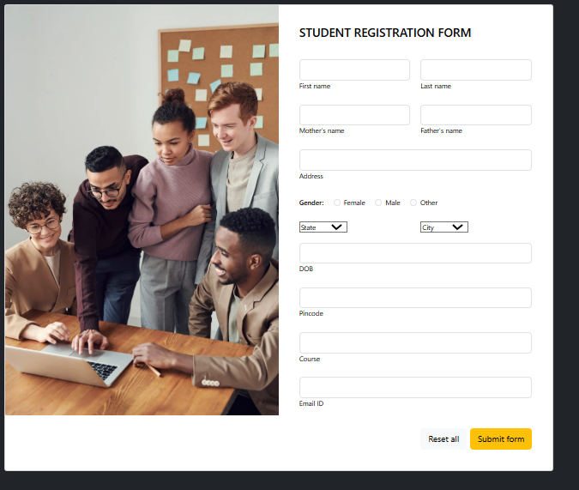

You can see our form is ready but we will make some customizations as per our need.
I will remove this image and I will remove this course field as well.
This state and city field as well as.
Now we will get back to our vscode
We will remove or comment the image div as below
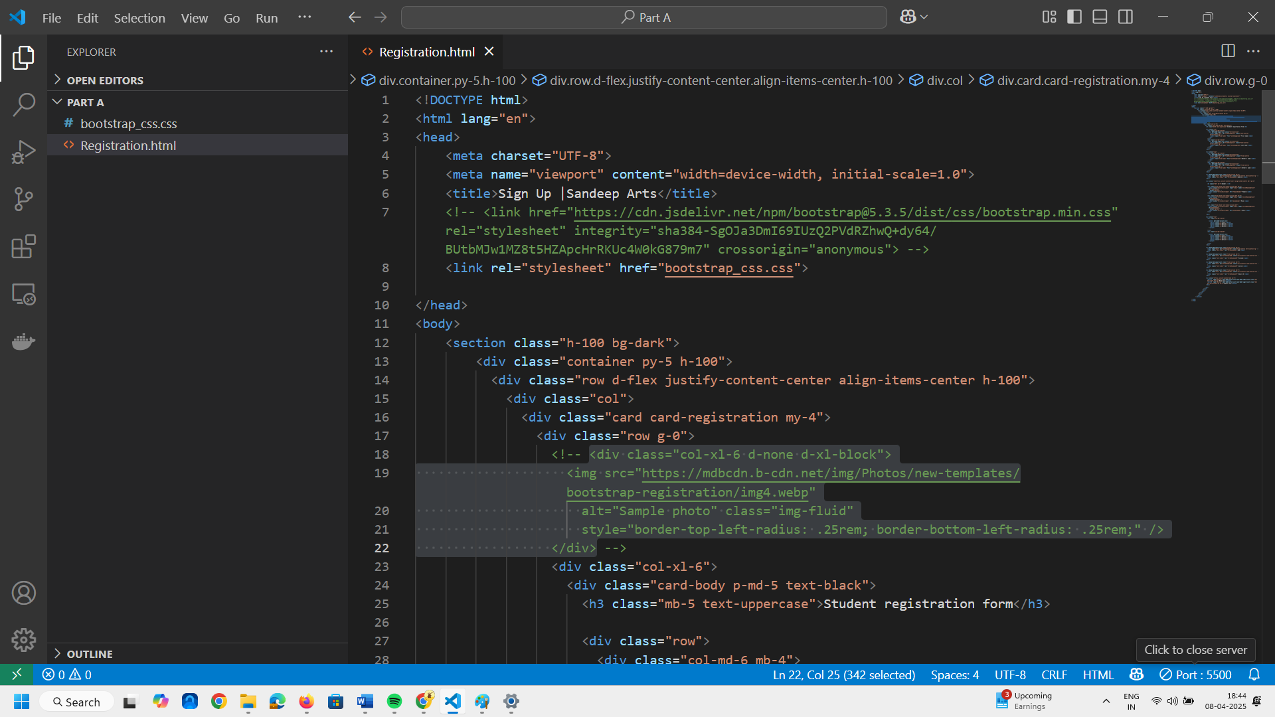
Now we can see our image has gone You can remove as many fields as you want.

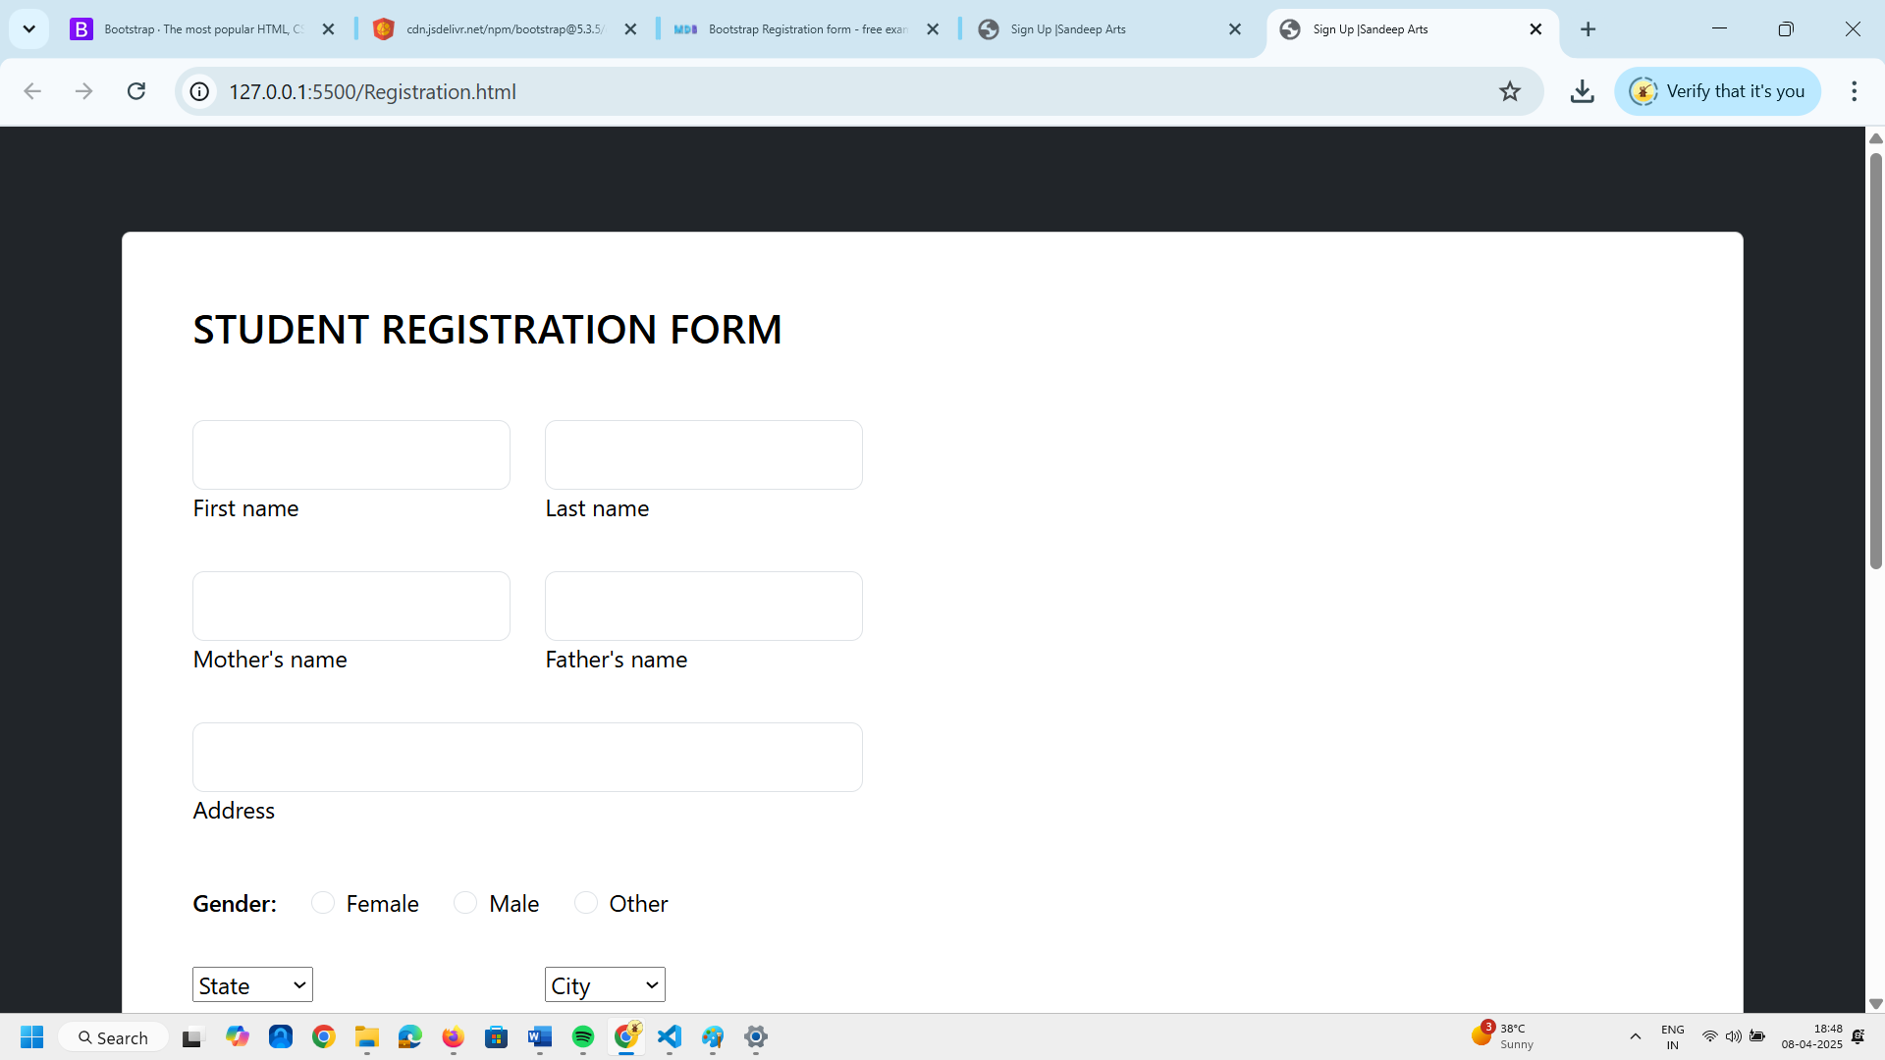
Now I want all the fields to take over whole page.
Online number 23 i.e <div class="col-xl-6">
Here change 6 to 12
<div class="col-xl-12">
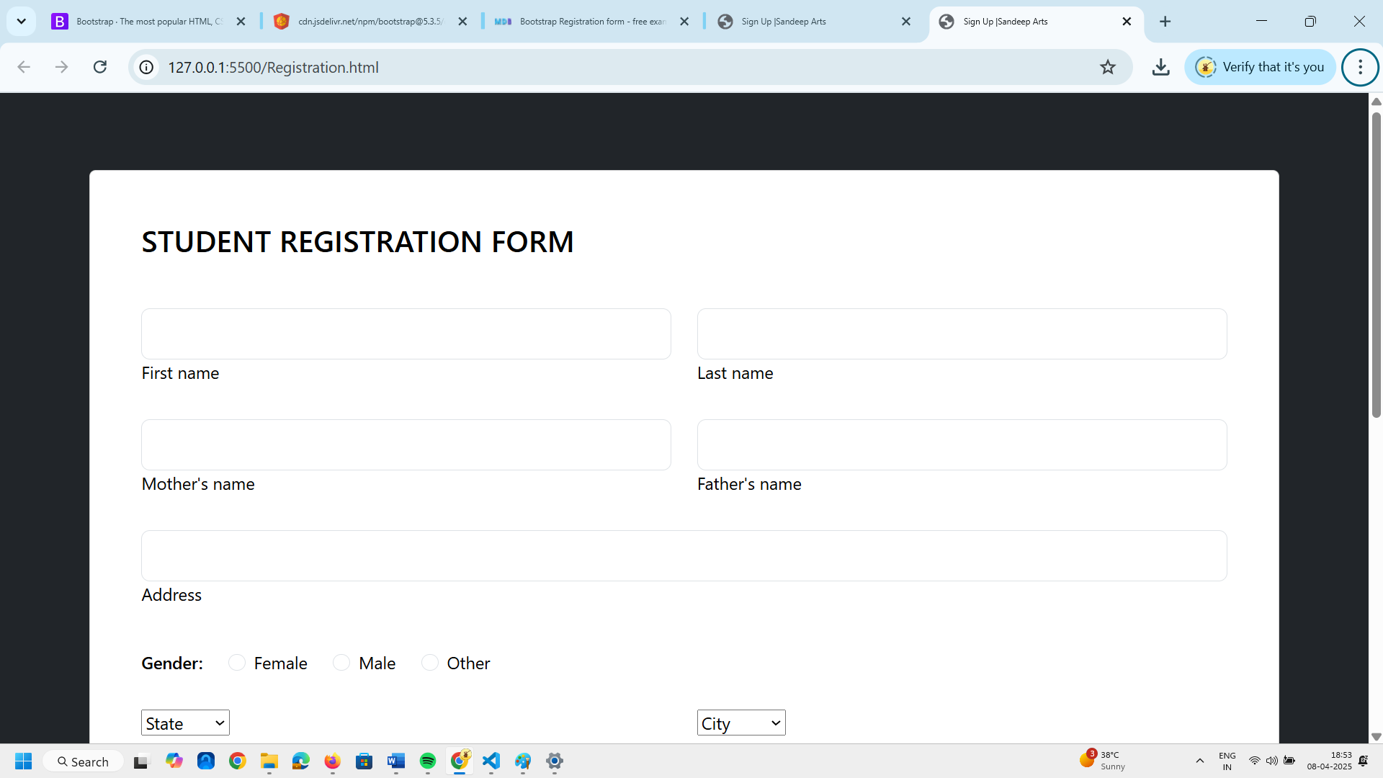
The field sizes are increased which will cover the whole page.
Next I will remove the fields mother name and father’s name.
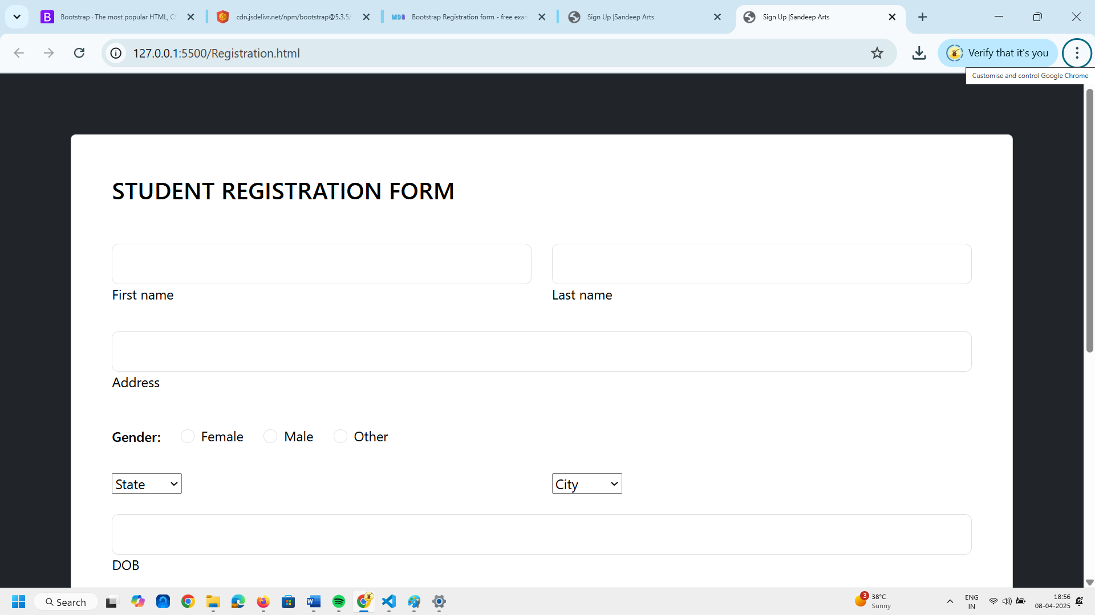
Motehr and Fathers name fields are removed.
Now we have to remove this state and city as well.
Search for state and city in the code.
Now comment this lines code as below.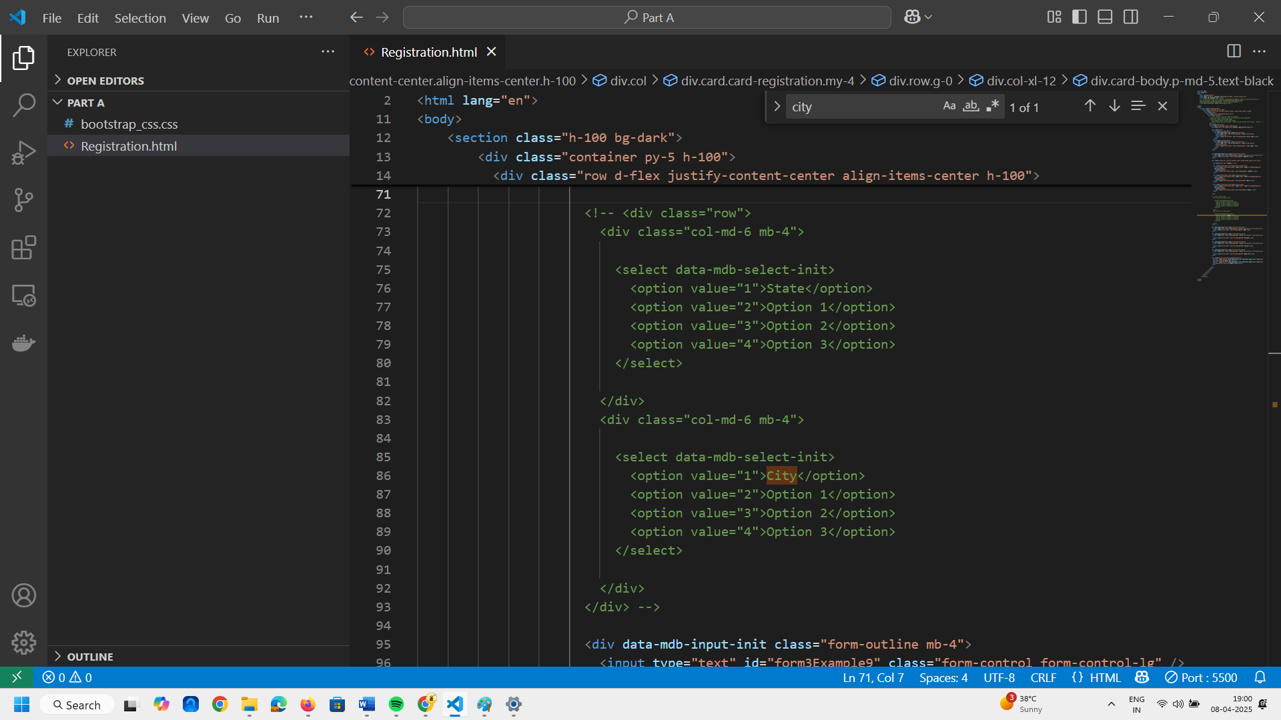
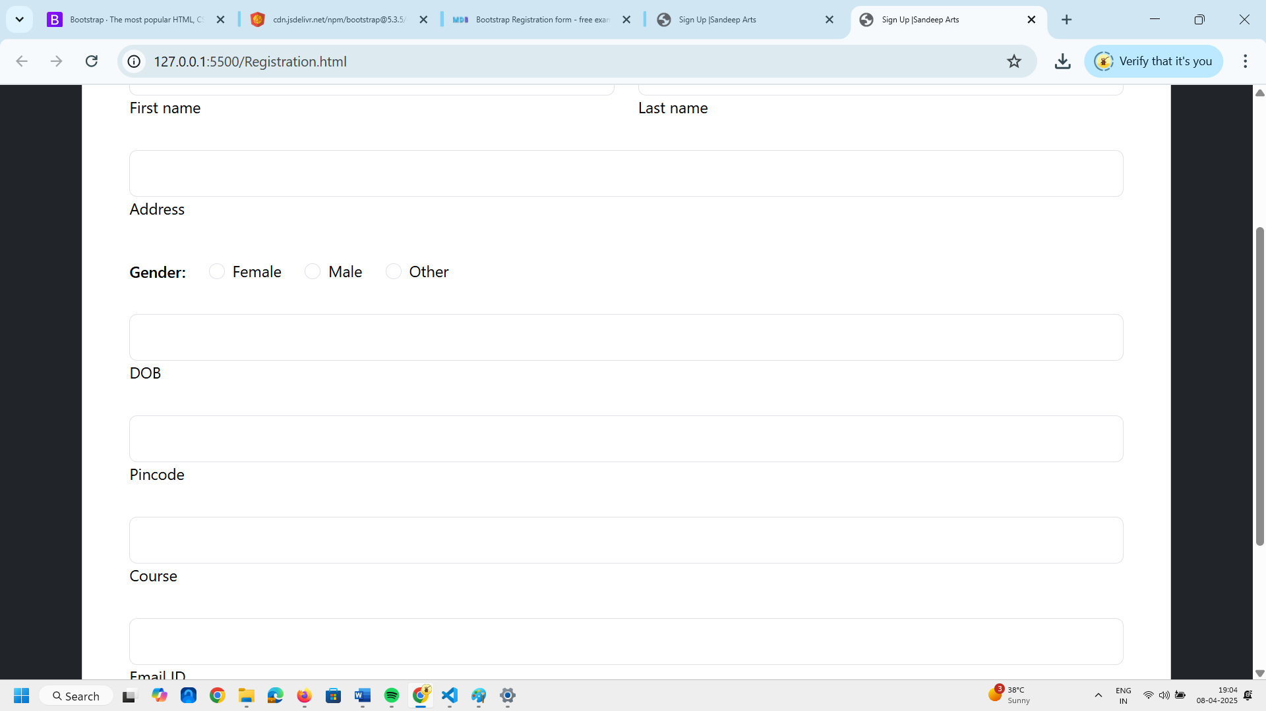

Now we can see here city and state disappeared.
Next is to remove course field.
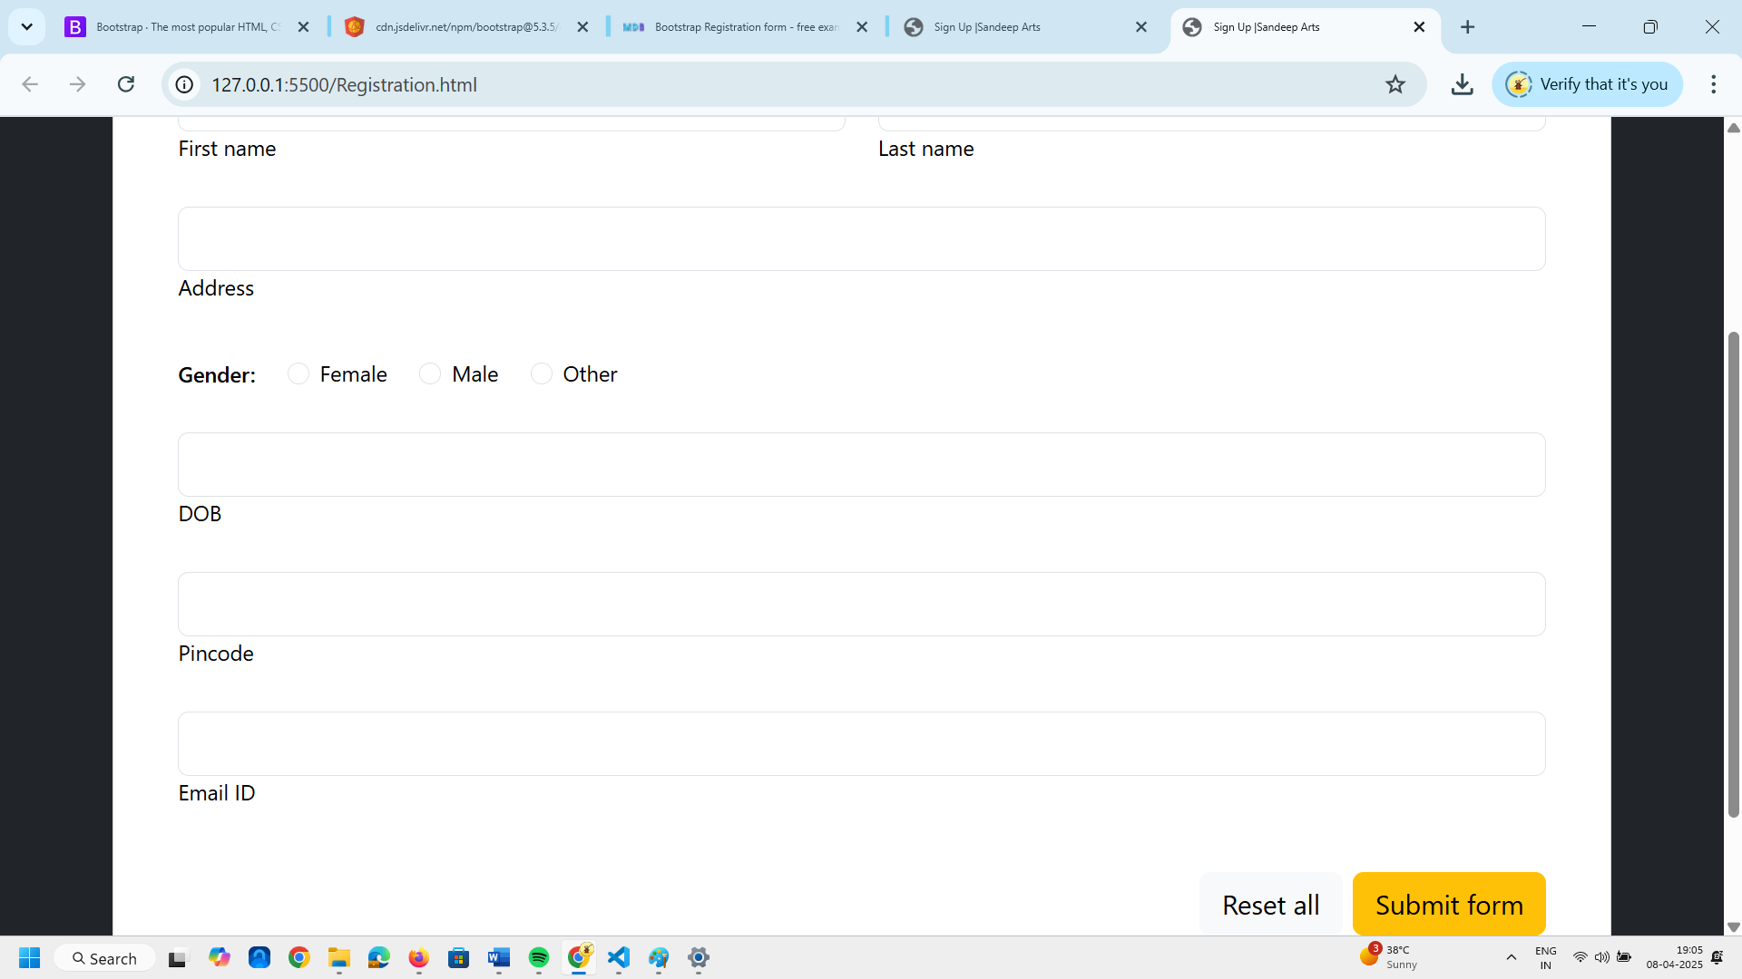
Course field is removed.
Below this email field I will add password and confirm password field.

Copy the email id division code and paste it twice
Replace email id with password and confirm password fields .
<div data-mdb-input-init class="form-outline mb-4">
<input type="text" id="form3Example97" class="form-control form-control-lg" />
<label class="form-label" for="form3Example97">Password</label>
</div>

<div data-mdb-input-init class="form-outline mb-4">
<input type="text" id="form3Example97" class="form-control form-control-lg" />
<label class="form-label" for="form3Example97">Confirm Password</label>
</div>

Now we need to change the input type from text to password.
<div data-mdb-input-init class="form-outline mb-4">
<input type="pasword" id="form3Example97" class="form-control form-control-lg" />
<label class="form-label" for="form3Example97">Password</label>
</div>

<div data-mdb-input-init class="form-outline mb-4">
<input type="password" id="form3Example97" class="form-control form-control-lg" />
<label class="form-label" for="form3Example97">Confirm Password</label>
</div>

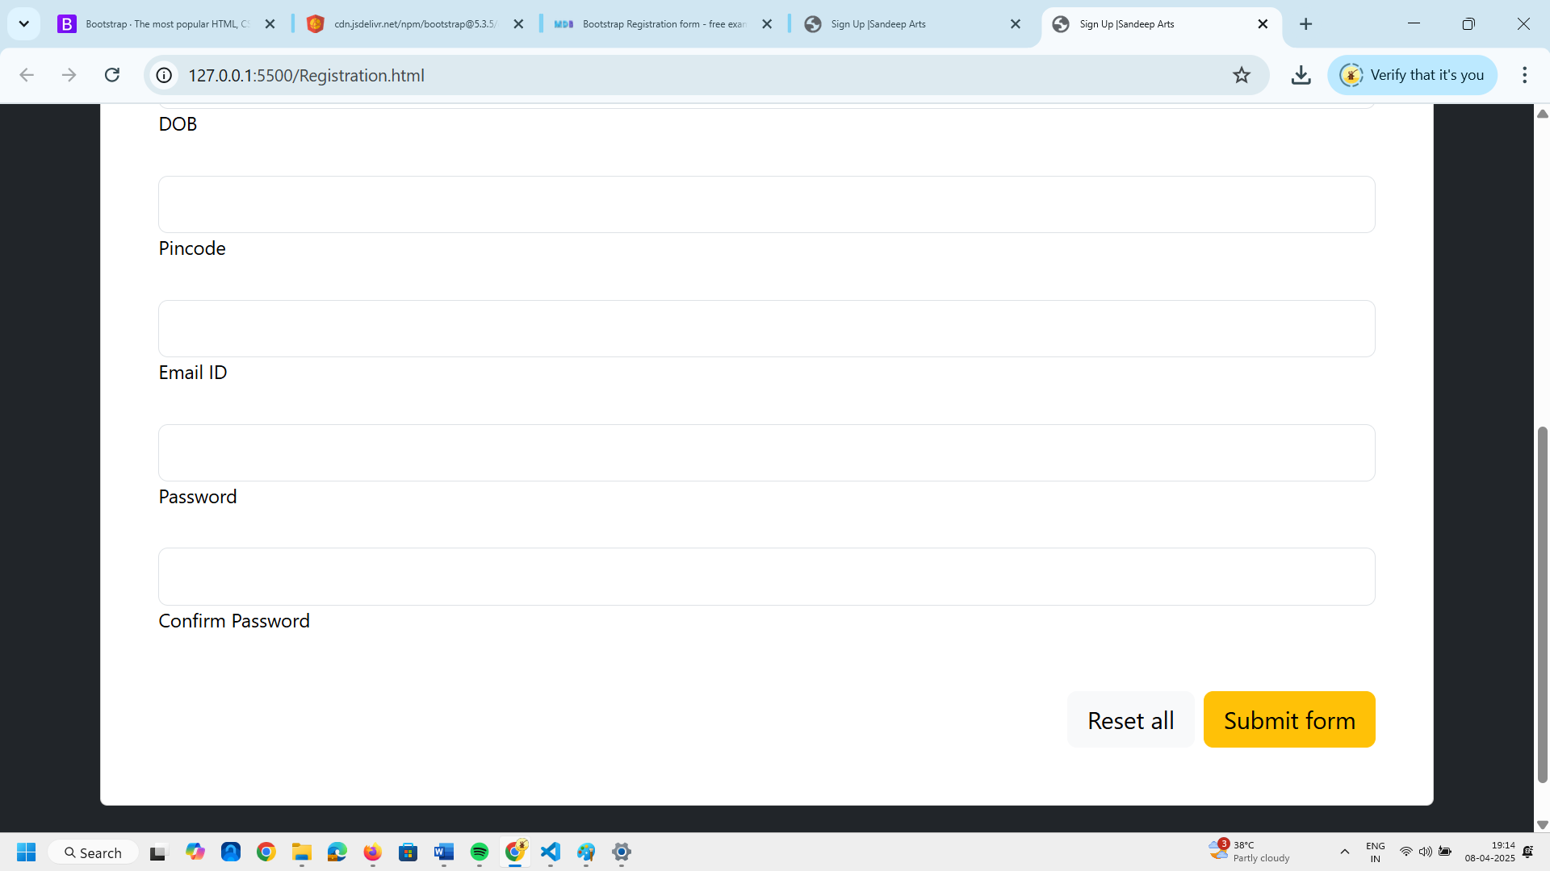
Now we will remove the Reset All button.
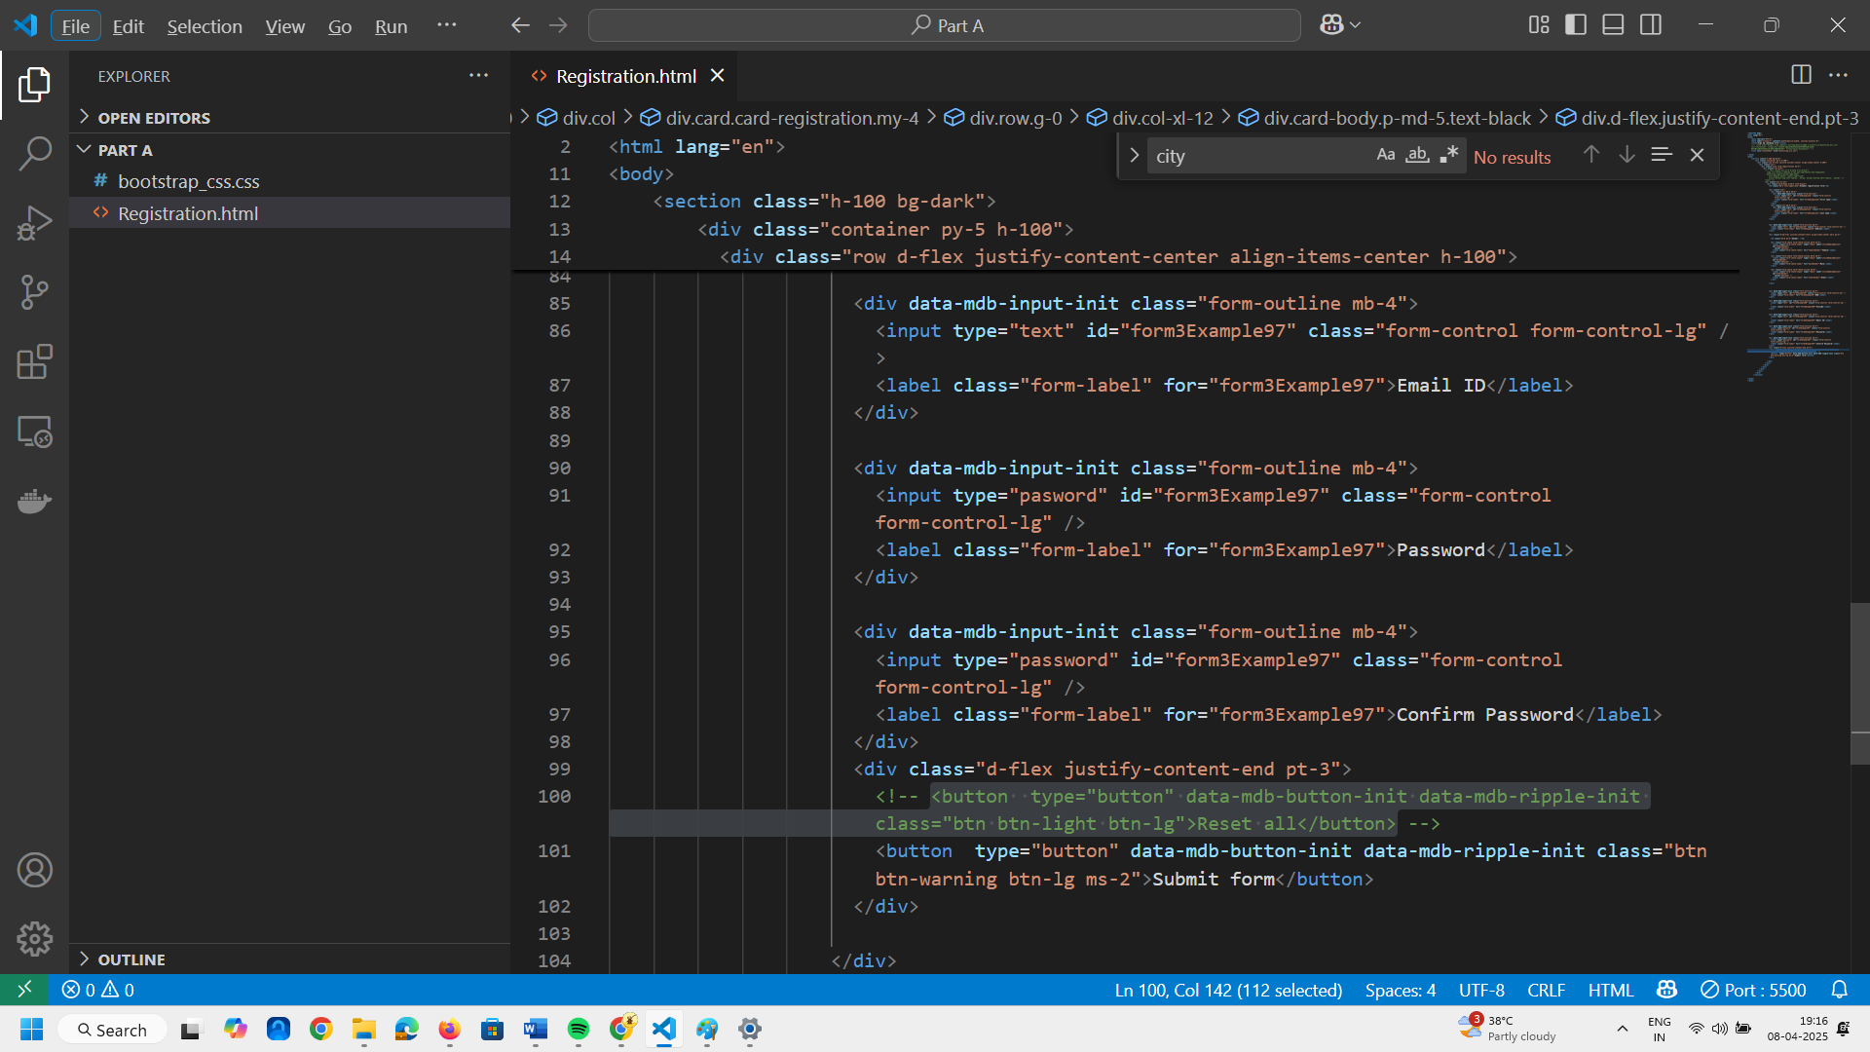
Remove or comment the Reset All button code as in above image.
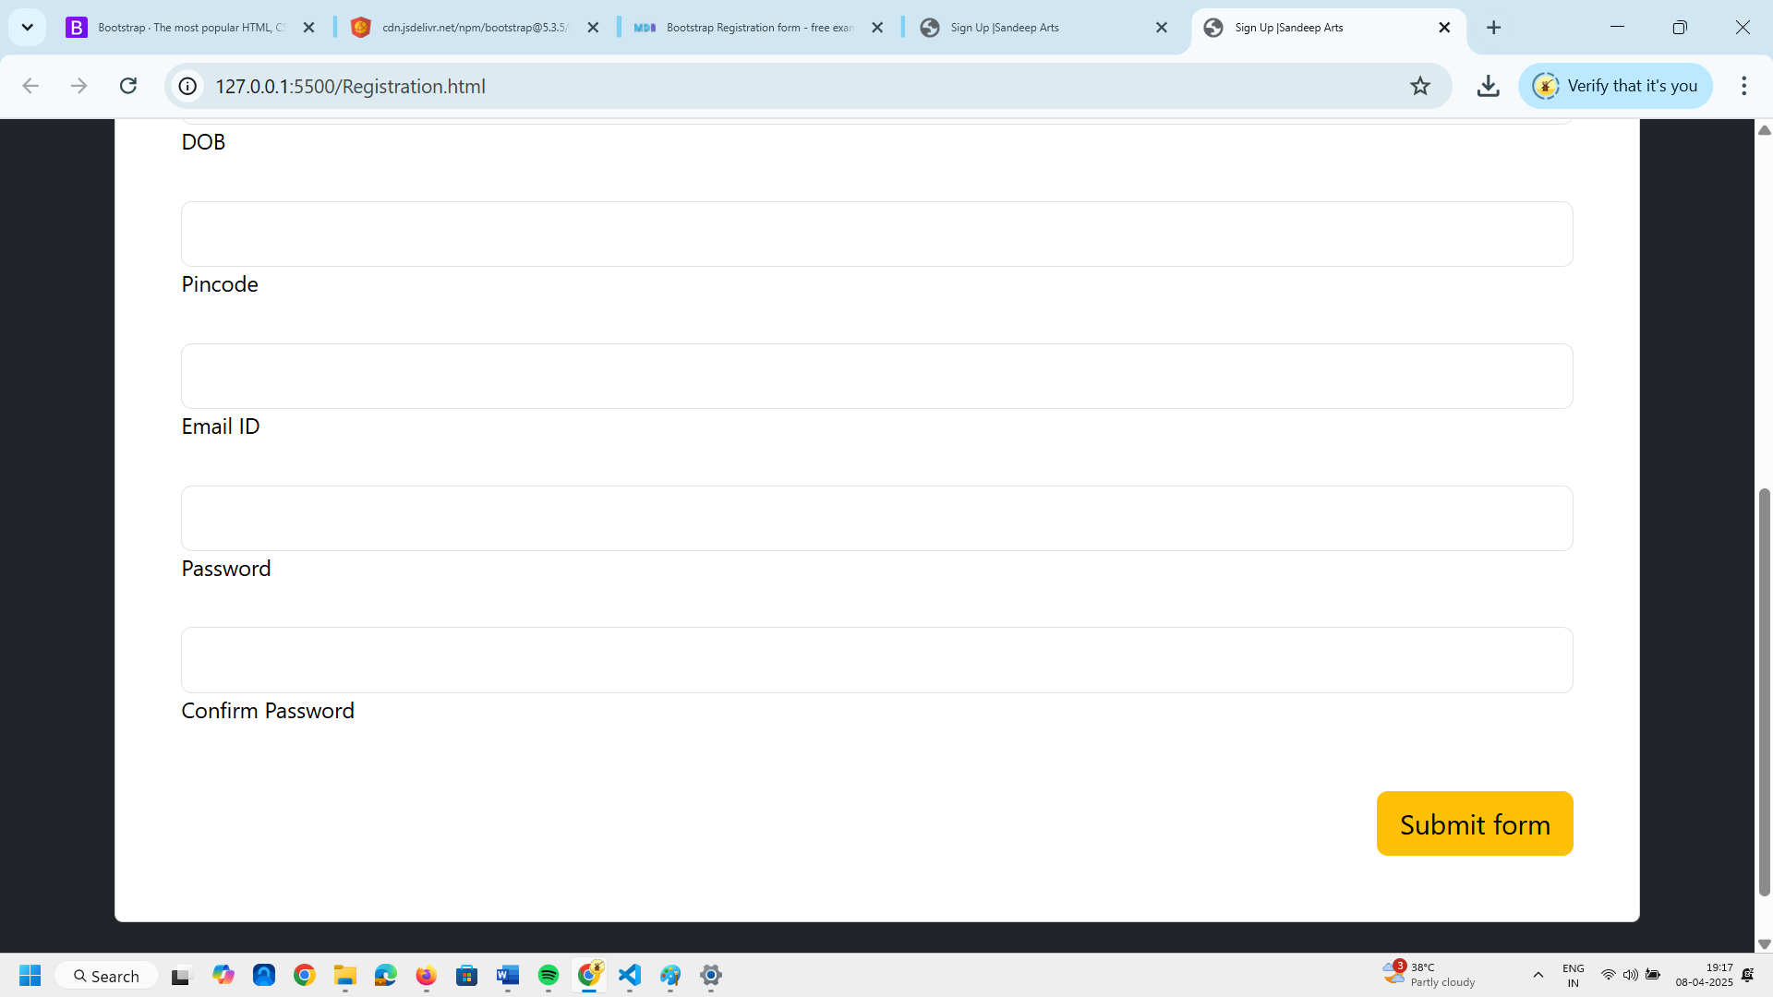
Now next task is to get the submit form to the center.
To make above modifications <div class="d-flex justify-content-end pt-3">
Remove pt-3 and end to center.
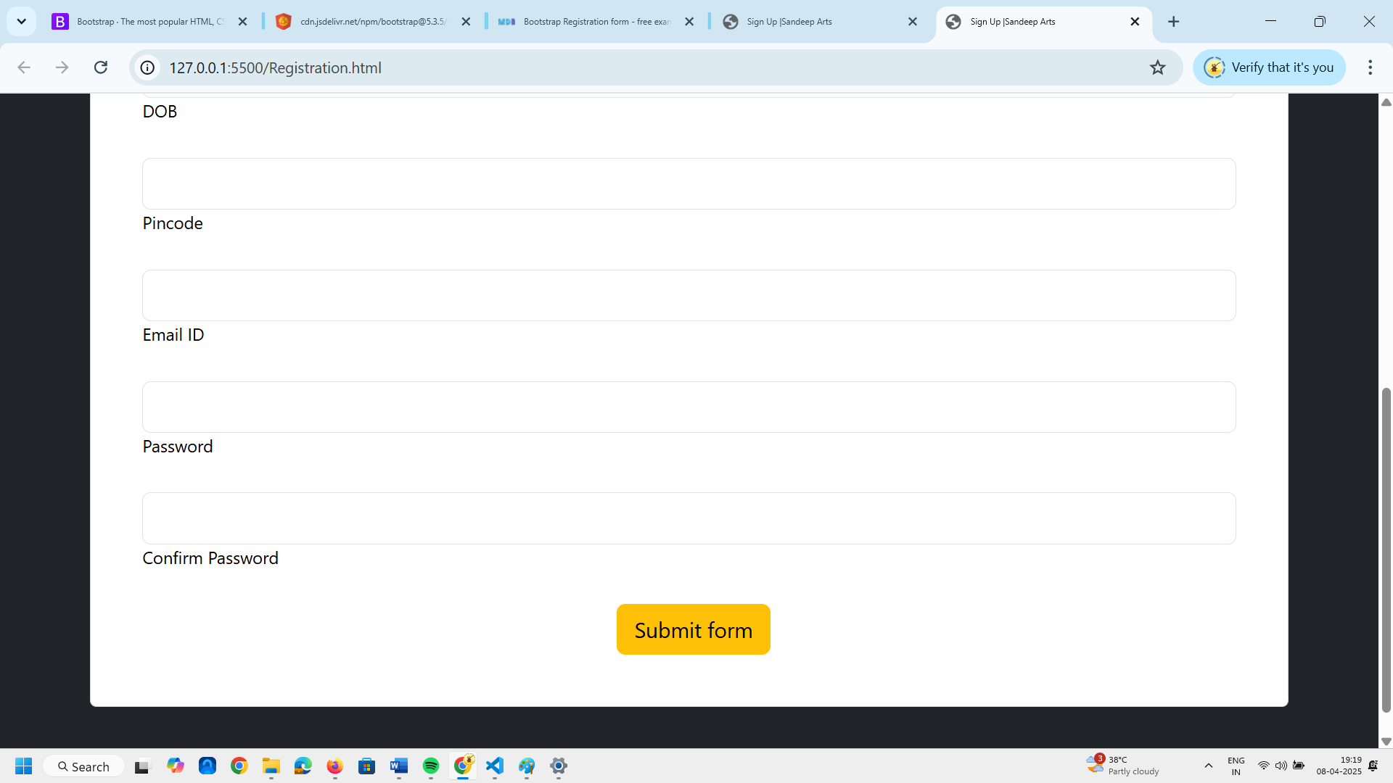
WE will replace the Submit Form text to Sign Up.
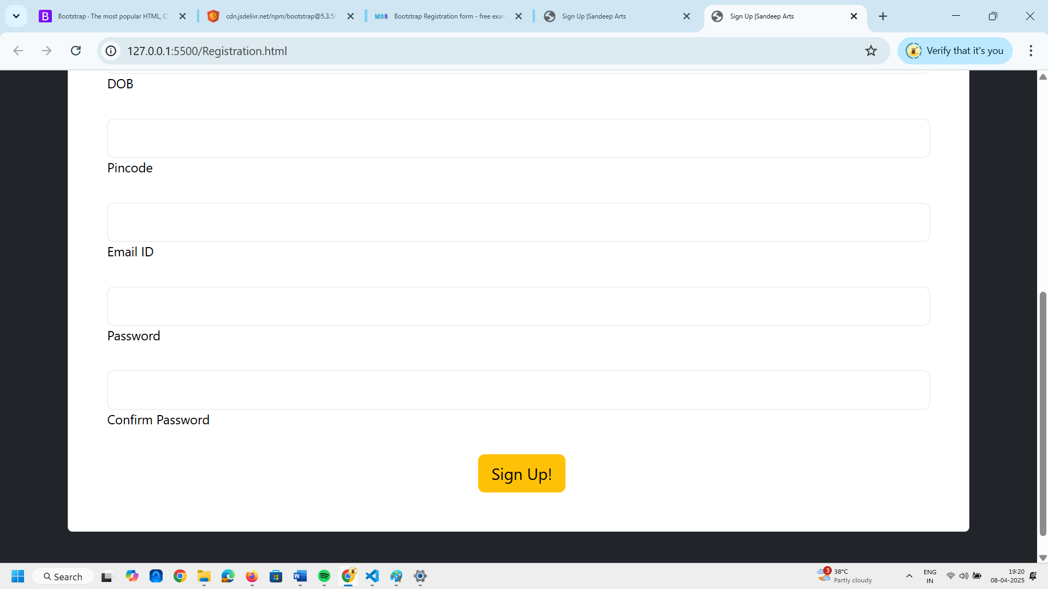

Next we will change the Student Registration Form Heading to Sign Up Form

Now I will change the color of Sign Up Form to the color of Sign Up Button on web page.
To do this we need to add an extension in your browser color picker.
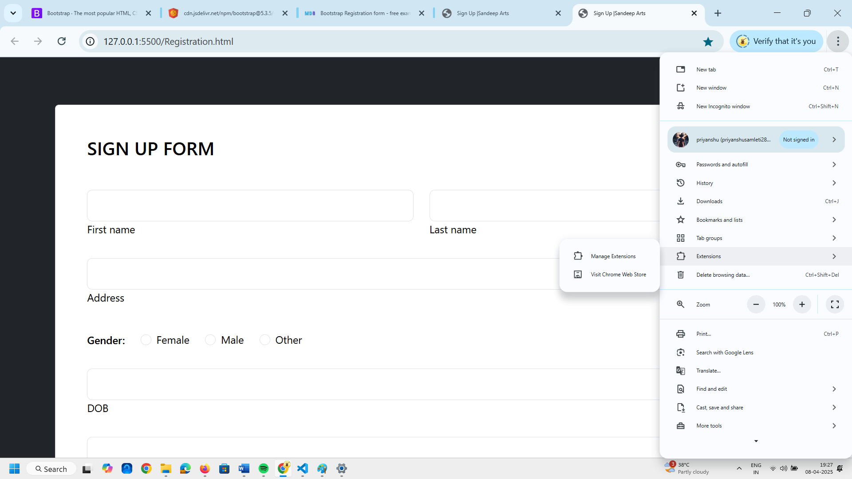
Click on Visit Chrome Web Store.
Or click on three dots then select
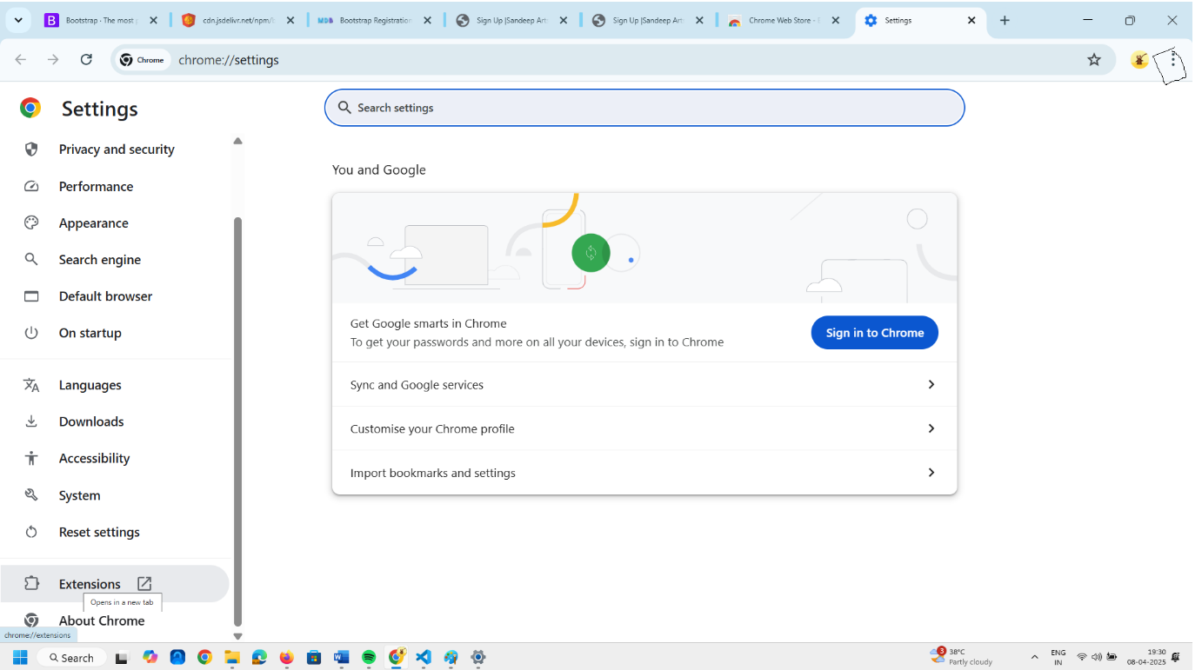
Click on extension on Left bottom side of browser.

Click on Chrome Web Store.
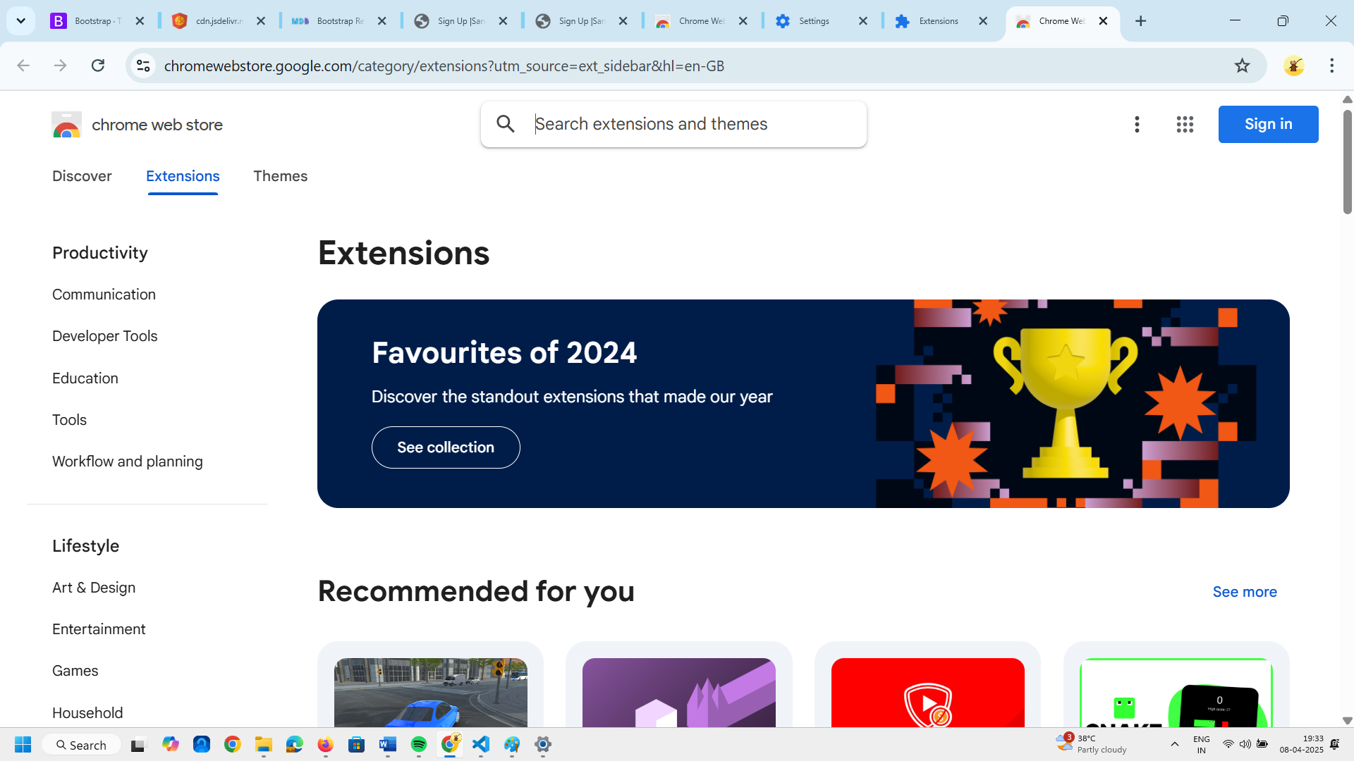
Type here required extension. HEX Color Picker add to chrome if it is not added already.
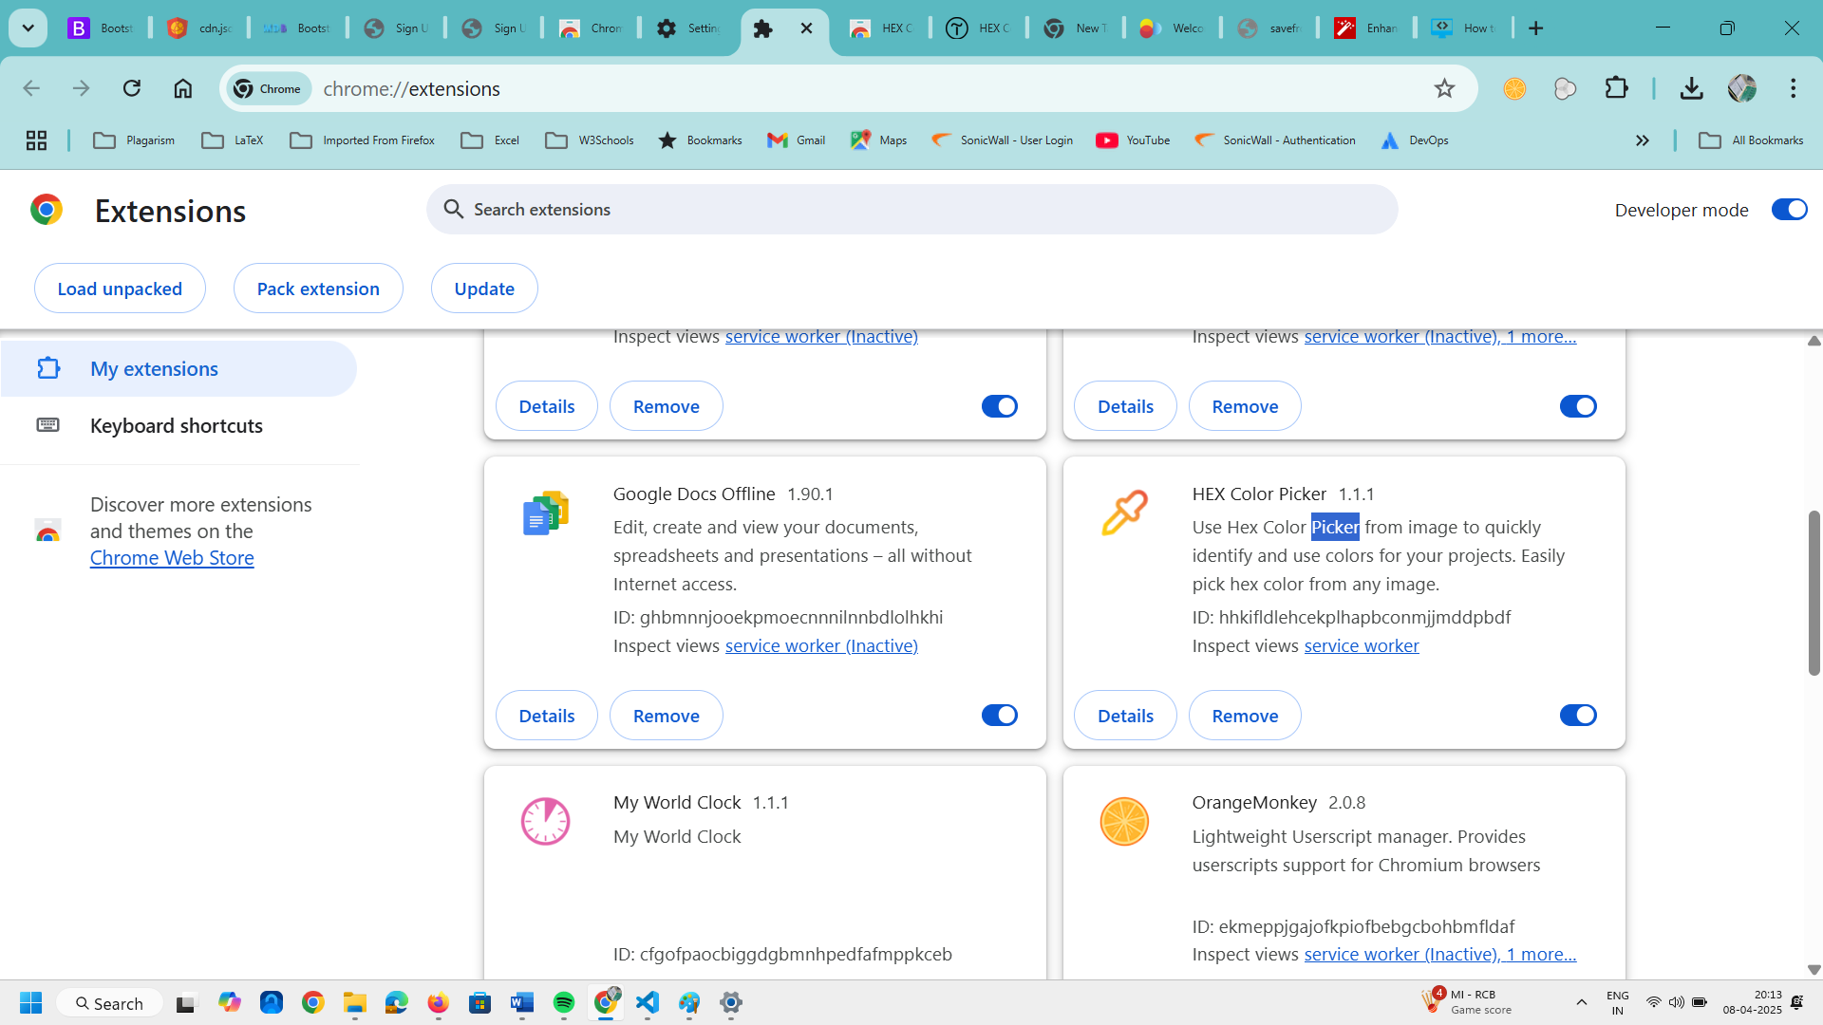
You can see above extension being added.
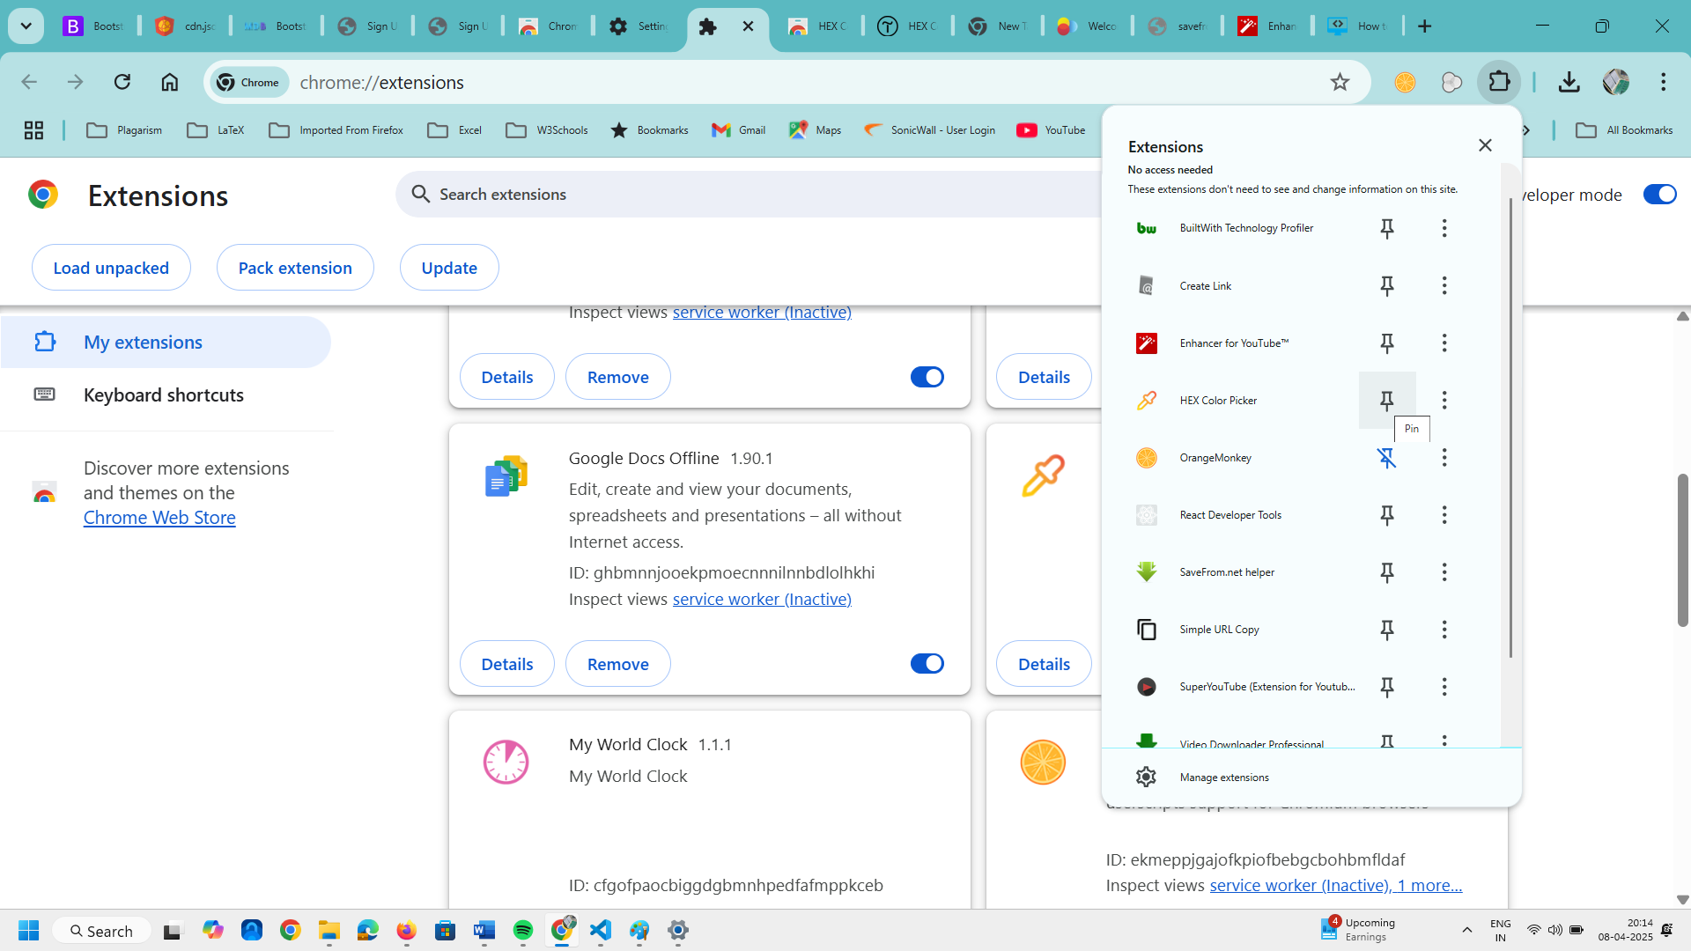
Extension being pinned.
Now I will go the webpage from where we have copied the code.
Now I will activate this extension. My extension is ready. I want to pick the colo.r Select the picker then activate the color by Pick a color. I will take my pointer to that button.
After clicking my color gets captured. I will copy the code as below.
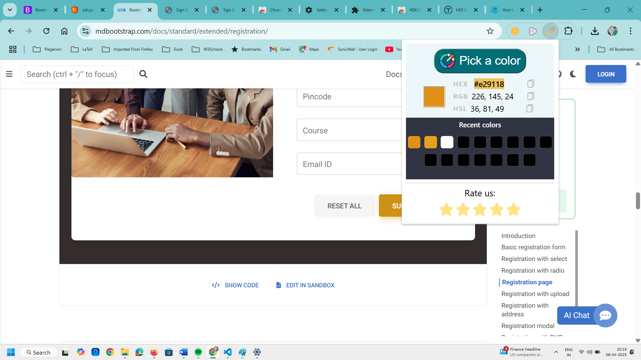
I will go to visual studio code editor and add color property inside the code on line
<h3 class="mb-5 text-uppercase" >Sign Up Form</h3>
Here as <h3 class="mb-5 text-uppercase" style="color:#e29118;">Sign Up Form</h3>
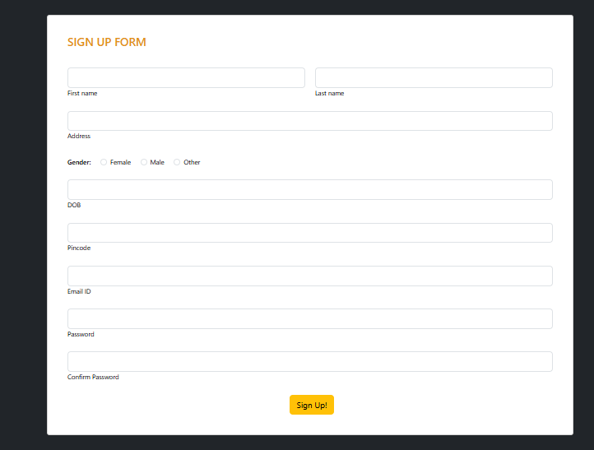

Now I will take the labels First Name and Last Name above the text box. For that what I will do is I will go to VSCode editor.
Here I will search for the label of First Name and Last Name
Shift the label code line to above the input line and if you want shift multiple labels lines of label just hold on the ALT key and click before these labels and click on each label line you will get multiple cursors.
Holding the ALT key press the upper Arrow Key.
Instead of this I will manually shift the label line above the input type line.
After shifting all the labels above the input type our web page will look like this.
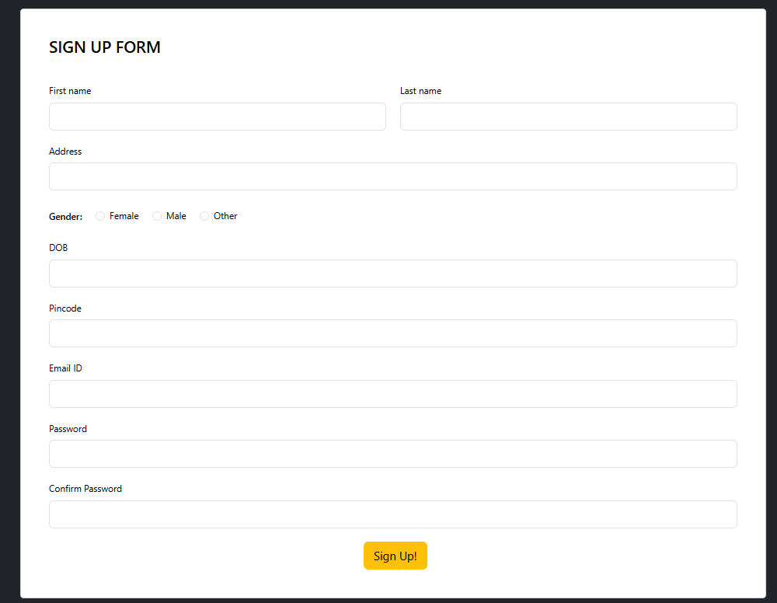
If you want you can add placeholder inside the text box as below
Inside the input type add the attribute placeholder=”Enter your First Name”
placeholder="Enter your Last Name"

Now save it and refresh the browser.

